

Health and safety policy


For all staff

Contents
Foreword 3
1 Policy statement 4
2 Organisational responsibilities 5
2.1 The NHBC Group Board 6
2.2 The chief executive 7
2.3 Executive Committee 7
2.4 Executive director with responsibility for
health and safety 7
2.5 Heads of functions and departments 7
2.6 Line managers 8
2.7 All employees 8
2.8 Head of health and safety 9
2.9 Appointed persons 9
2.10 NHBC Group Health, Safety and Wellbeing Committee 10
2.10.1 Membership 10
2.10.2 Secretariat 10
2.10.3 Meetings 10
3 Health and safety arrangements 11
3.1 Document issue and control 11
3.2 Application 11
3.3 Planning 11
3.3.1 Hazard identification, risk assessment and risk control 11 3.3.2 Legal and other requirements 11
3.3.3 Objectives 11
3.4 Implementation and operation 12
3.4.1 Training, awareness and competence 12
3.4.2 Consultation and communication 12
3.4.3 Operational control 13
3.4.4 Emergency procedures 13
3.4.5 Discipline 13
3.5 Performance measurement and monitoring 14
3.5.1 Monitoring of safety performance 14
3.5.2 Accident/incident reporting and investigation 14
3.5.3 Accident and incident analysis 14
3.5.4 Auditing 14
3.5.5 Management review 14

NHBC Health and safety policy Page 2

Foreword

This health and safety policy for the National House-Building Council (NHBC), NHBC Building Control Services Limited, NHBC Services Limited and its active UK registered subsidiaries (collectively the NHBC Group), is a declaration of NHBC Group’s intent for health and safety management and aims to assist all employees in meeting the legal requirements in line with
the health and safety policy statement.
As an employer, NHBC Group will ensure, so far as is reasonably practicable, the health and safety at work of all its employees. In addition, NHBC Group will conduct its undertakings in such
a way as to ensure, so far as is reasonably practicable, that people not in its employment who may be affected by its undertakings are not exposed to risks to their health or safety. NHBC Group also recognises that every employee, whilst at work, must take reasonable care of their own health and safety and that of anyone else who may be affected by their work.
The main responsibility for ensuring the health and safety of employees, and for reducing risk to others, rests with NHBC Group as the employer, under the requirements of the Health and Safety at Work etc. Act 1974 (HSW Act).
The general duties of employers under the HSW Act are supplemented by a number of health and safety regulations that will be monitored for changes by NHBC Group on a regular basis. In order to ensure the health and safety of our activities, we will:
l assess the work-related risk to employees and others that may be affected by our
undertakings
l have effective arrangements in place for the planning, organisation, controlling, monitoring
and reviewing of preventative and protective measures
l appoint a competent person to help in undertaking the measures needed to comply with
health and safety law
l provide employees with comprehensible and relevant information on the risks they face and
the preventative and protective measures that control these risks.
All contractors employed by NHBC Group will be required to demonstrate a similar commitment
to the management of health and safety.
The health and safety policy consists of three parts:
1
Health and safety policy statement – the declaration of intent, signed by the chief executive,
which sets out the required standards of health, safety and welfare to be achieved across the
NHBC Group, and the management’s commitment to those standards.

Organisational responsibilities – details of the health and safety responsibilities across the company.
2
3 Arrangements for health and safety – the systems the company has in place to assist in
ensuring health and safety management in the workplace.

NHBC Health and safety policy Page 3

Policy statement


1 Policy statement

NHBC Group is committed to a policy of effectively managing all aspects of occupational health, safety and wellbeing. This commitment extends to all business units, workplaces, employees and others affected by our operation.
As an employer, we recognise and accept our responsibility to ensure the health, safety and welfare at work of all employees, visitors and contractors, so far as is reasonably practicable. NHBC Group recognises that achieving high standards of health and safety is an integral part of business performance and, whilst all statutory provisions will be complied with, the company will take all reasonably practicable measures to ensure continual improvement of health and safety standards. We are committed to the elimination of hazards and reducing health and safety risks.
The NHBC Group boards of directors (Boards) have overall responsibility
for health, safety and welfare and will ensure that such resources, facilities, finance, information, instruction, training and supervision are provided as is necessary to maintain a positive health and safety culture and performance.

Consequently, line managers are expected to perform an important function within the overall implementation of this policy by demonstrating a positive, proactive approach to health and safety and by ensuring that this policy, together with its associated procedures, is clearly communicated to employees and then implemented, monitored and reviewed.
NHBC Group is committed to maintain its Occupational Health and Safety (OH&S) Management System in compliance with ISO 45001:2018 and the continual improvement of its OH&S management system and performance. NHBC group is also committed to managing and assessing all levels of risk both from a physical and mental wellbeing aspect and acting accordingly to ensure the positive culture of continual improvement remains.
All employees and others involved in NHBC Group’s activities, are expected to co-operate with NHBC Group in the implementation of this policy and will ensure that their own work, so far as is reasonably practicable, is carried out without risk to themselves or others. To facilitate the understanding of our policy, standards and objectives, NHBC Group will ensure that there are arrangements for effective communications, consultation and participation of workers and, where they exist, workers representatives. Generally, this will be via the Health, Safety and Wellbeing Committee.
In promoting a positive health and safety culture, NHBC Group will set clear annual targets and objectives for occupational health and safety. Progress towards the achievement of these objectives will be reported at each meeting of the NHBC Group Board. The health and safety policy is regularly monitored and developed and will be formally reviewed annually, though by exception, amendments may be implemented at other times as required by legislative changes or work practices.
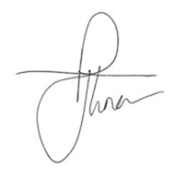
The NHBC Group policy statement will be displayed prominently in all workplaces. The organisation
and arrangements for the implementation of the policy will also be available at all workplaces for reference by any employee if required.

Paul Turner
Chief Executive Officer (executive director with responsibility for health and safety) NHBC
September 2026
NHBC Health and safety policy Page 4

Organisational responsibilities

2 Organisational responsibilities
The NHBC Group Boards have overall responsibility for ensuring that arrangements exist to ensure, so far as is reasonably practicable, that the undertakings of NHBC Group are executed without
risk to the health and safety of those engaged in, or affected by, its operations. For all practical purposes, the NHBC Group Boards will rely on the Executive Committee (ExCo) for the safe and healthy execution of NHBC Group’s business operations. Within each of NHBC’s directorates, managers have a responsibility for the health and safety matters in their area of operation. Responsibilities have been outlined in this document for each of the following roles:
2.1
The NHBC Group Boards – those people who are appointed as executive or non-executive
directors of NHBC or its subsidiaries.
2.2 Chief executive officer – the person who holds the post of chief executive of NHBC Group
and the NHBC Group executive director with responsibility for health and safety – the person
named by the Board as having particular responsibility for health and safety matters.
2.3

Executive Committee (ExCo) – executive leaders from across NHBC Group.
2.4

2.5

Executive director with responsibility for health and safety – the person named by the Board as having particular responsibility for health and safety matters.
Head of department/function – those persons who have the job title ‘Head of’, or those who, from time to time, attend leadership group meetings.
Group Head of health and safety – the Person with delegated responsibility for health and safety
2.6
2.7 Line managers – all managers (including, where appropriate, the chief executive, ExCo and
heads of department) who have management responsibility for other members of staff.
2.8 Appointed persons – persons with responsibility for co-ordinating health and safety matters
relating to the premises, in each of NHBC’s office or warehouse locations.
2.9 All personnel – all those who work for NHBC Group, including directors, full-time and part-
time employees, contract and temporary staff (whether directly employed or agency staff).
2.10
Health, Safety and Wellbeing Committee – a consultative body that monitors health, safety
and wellbeing performance across the organisation, ensuring compliance with NHBC Group’s
health and safety policy, wellbeing policies and best practice relevant to legislation.

2.11

Document review team – consultative body made up of members from the health and safety to assist with reviewing of health and safety documentation

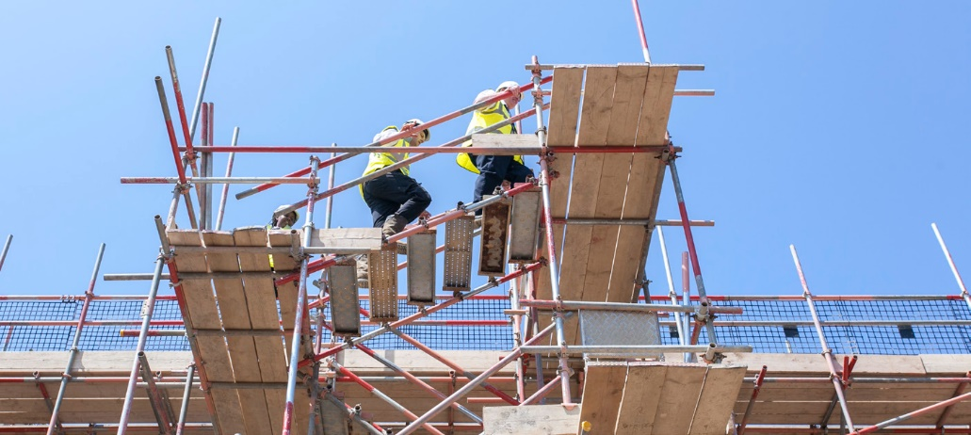

NHBC Health and safety policy Page 5

Organisational responsibilities

2.1 The NHBC Group Boards
In meeting the requirements of NHBC Group’s health
and safety policy, the NHBC Group Boards will ensure
the development and implementation of arrangements
and control systems to ensure that the undertakings of NHBC Group are executed, so far as is reasonably practicable, without risk to the health and safety of
those engaged in, or affected by, its operations, and will: a) ensure the provision of this policy is kept under
review having regard to changes in legislation, best practice and NHBC Group’s business
b) include health and safety on Board meeting agendas, monitor NHBC Group’s health and safety
performance and respond accordingly
c) appoint an executive director to be responsible for
health and safety
d) ensure appropriate arrangements are in place
for the provision of competent health and safety advice and that health and safety arrangements are adequately resourced
e) accept their collective and individual roles in providing health and safety leadership and being a
role model to all employees, at all times, in respect of health and safety management
f) ensure that strategic direction takes account of
health and safety management, systems and arrangements
g) ensure they maintain the appropriate health and safety competence commensurate with their
position
h) provide the means to communicate with, and
action feedback from, employees and other stakeholders for health and safety arrangements and performance
i) review health and safety performance and
progress towards the achievement of the Group’s
annual health and safety objectives.

2.2 Chief executive officer
In meeting the requirements of NHBC Group’s health and safety policy, the chief executive officer will, where reasonably practicable:
a) ensure that an effective health and safety management system is maintained within NHBC
Group at all times
b) ensure that sufficient resources are available for
the implementation of this policy throughout NHBC Group
c) discuss and agree the annual NHBC Group health
and safety objectives with ExCo
d) ensure health and safety is on the agenda, as
appropriate, for business management meetings e) ensure that the general policy statement is
reviewed annually and, where necessary, revised and reissued
f) personally take charge of, or nominate a senior manager to lead, an enquiry for any fatal or
serious accident or incident involving NHBC Group personnel or operations
g) set a personal example with regard to health and
safety.

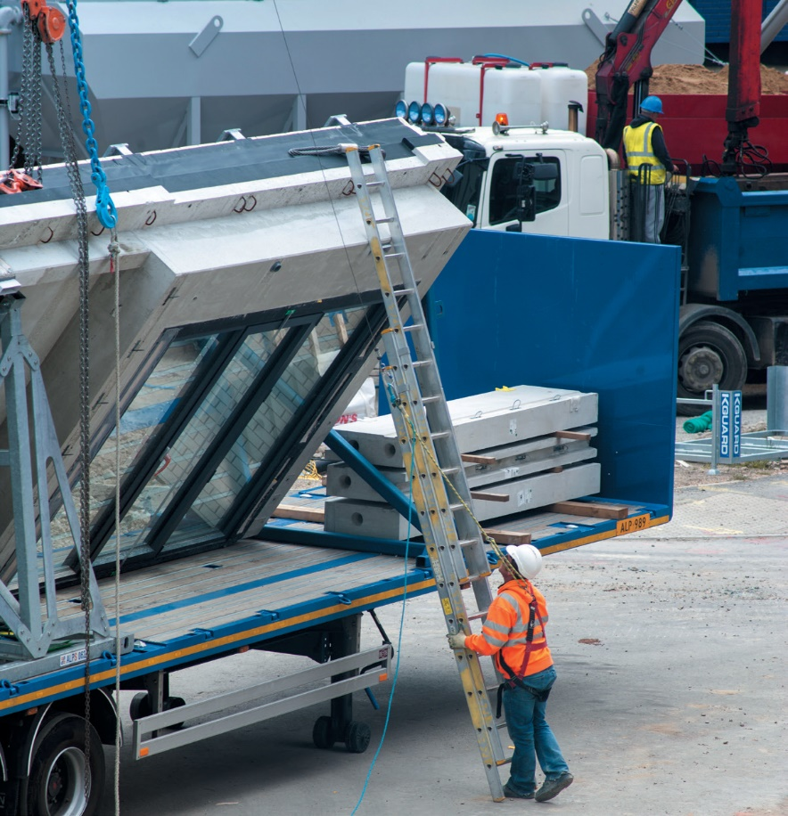

NHBC Health and safety policy Page 6

Organisational responsibilities

2.3 Executive Committee (ExCo)
In meeting the requirements of NHBC Group’s health and safety policy, the executive directors will, where reasonably practicable:
a) discuss and agree the annual health and safety
objectives with the chief executive
b) ensure the implementation of the NHBC Group
health and safety policy and related procedures within their directorate
c) delegate the day-to-day implementation of the health and safety policy and the achievement of its
objectives to line managers
d) ensure that resources, including training, are
provided to implement the health and safety policy and the achievement of its objectives
e) ensure that health and safety procedures
are developed and provided to support the
departments under their control
f) ensure that health and safety is an agenda item for
all management meetings
g) actively promote, at all levels, NHBC Group’s
commitment to effective health and safety management
h) set a personal example with regard to health and
safety.
2.4 Executive director with
responsibility for health and safety
In meeting the requirements of NHBC Group’s
health and safety policy, the executive director
with responsibility for health and safety will, where reasonably practicable:
a) champion health and safety matters at Board level b) receive and review health and safety reports from
the Group head of health and safety
c) provide the NHBC Group Boards with an annual
report on health and safety performance.

2.5 Heads of function/department
In meeting the requirements of NHBC Group’s health and safety policy, heads of function will, where reasonably practicable:
a) be aware of the health and safety policy
requirements affecting NHBC Group’s operations and seek further advice when necessary
b) delegate, through the line management function,
duties and responsibilities necessary for the implementation of the health and safety policy and the achievement of its objectives
c) discuss and agree the implementation of the
health and safety policy and the achievement of its
objectives for the areas under their control with the executive director
d) discuss and agree the implementation of the
health and safety policy and the achievement of its
objectives with line managers
e) ensure that resources, including training, are
provided to implement the health and safety policy and the achievement of its objectives
f) ensure that any procedures relating to the management of health and safety, in areas of their
control, are complied with
g) ensure that health and safety is on the agenda, as
appropriate, for management meetings
h) ensure that procedures relating to the safety of
staff visiting sites are complied with
i) ensure that accidents and incidents that occur
within their areas of responsibility are reported, investigated and appropriate action(s) taken to avoid repetition
j) take the appropriate actions under NHBC Group disciplinary procedures with regard to any member
of staff not complying with NHBC Group’s health
and safety policy, procedures or general safe working practices
k) report any problems with, or improvements
required to, this policy
l) actively promote at all levels, NHBC Group’s
commitment to effective health and safety management
m) set a personal example with regard to the health
and safety.

NHBC Health and safety policy Page 7

Organisational responsibilities

2.6 Line managers
In meeting the requirements of NHBC Group’s health and safety policy, line managers will, where reasonably practicable:
a) be aware of the health and safety policy
requirements affecting NHBC Group’s operations
and seek further advice when necessary
b) discuss and agree the requirements of the health
and safety policy and the achievement of its objectives for the areas under their control with their line managers
c) ensure that resources, including training, are identified to implement the health and safety policy
and the achievement of its objectives
d) ensure that health and safety is on the agenda, as
appropriate, for staff and team meetings
e) participate in accident and incident investigations
in accordance with the accident and incident procedure
f) report any problems with, or improvements required
to, this policy
g) ensure that health and safety procedures are
implemented for areas under their control
h) give guidance to members of staff on how to
access NHBC Group’s health and safety procedures i) take the appropriate actions under NHBC Group
disciplinary procedures with regard to any member of staff not complying with NHBC Group health and safety policy, procedures or general safe working practices
j) actively promote, at all levels, NHBC Group’s commitment to effective health and safety management
k) set a personal example with regard to health and
safety.

2.7 All employees
In meeting the requirements of NHBC Group’s health and safety policy, all employees have a duty and obligation to take reasonable care of their own health and safety and that of others who may be affected
by their acts or omissions. NHBC Group expects
a reasonable and responsible attitude from all employees towards meeting their health and safety obligations at work.
All employees should, where reasonably practicable:
a) be conversant with the relevant requirements
identified in the NHBC Group health and safety
policy
b) carry out their work so that it does not endanger
themselves or others
c) undertake their work in accordance with any
information, instructions or training that has been provided
d) proactively participate in NHBC Group’s objective
of achieving and maintaining a positive health and
safety culture, and co-operate with line managers and colleagues in creating and maintaining a safe and healthy working environment
e) bring to the attention of line management any health and safety concerns about unsafe practices,
equipment or conditions
f) assist line managers in identifying their health and
safety training needs
g) set a personal example with regard to health and
safety.



NHBC Health and safety policy Page 8

Organisational responsibilities

2.8 Group head of health and safety
In meeting the requirements of NHBC Group’s health and safety policy, the Group head of health and safety will, where reasonably practicable:
a) ensure the chief executive officer and NHBC Group Boards are kept updated on all relevant health and
safety matters
b) give suitable and sufficient advice and assistance
on health and safety matters to the chief executive officer and NHBC Group
c) ensure an effective health and safety management
system is maintained, achieving, as a minimum, legislative compliance through effective practical policies and best practice procedures, and that this is deployed across all directorates
d) ensure that the health and safety policy and
related procedures are reviewed and amended
in accordance with legislative and organisational changes and ensure that the policy is reviewed annually
e) ensure that suitable arrangements are made and
implemented for the co-ordination of health and safety measures across NHBC Group’s directorates and activities
f) promote health and safety as a core business objective and seek to determine and promote best
practice across NHBC Group
g) provide advice, guidance and support on health
and safety matters to NHBC Group personnel when required to do so
h) undertake regular audits of NHBC Group health and
safety management arrangements and report the findings to ExCo

i) review all NHBC premises to ensure compliance
with statutory duties
j) provide feedback to the executive director
with responsibility for health and safety on the effectiveness of NHBC Group’s health and safety management systems and any improvements necessary
k) ensure suitable arrangements are in place to facilitate effective engagement with employees on
health and safety matters
l) support the Health, Safety and Wellbeing
Committee, as required
m) actively promote, at all levels, NHBC Group’s
commitment to effective health and safety management
n) set a personal example with regard to health and
safety.

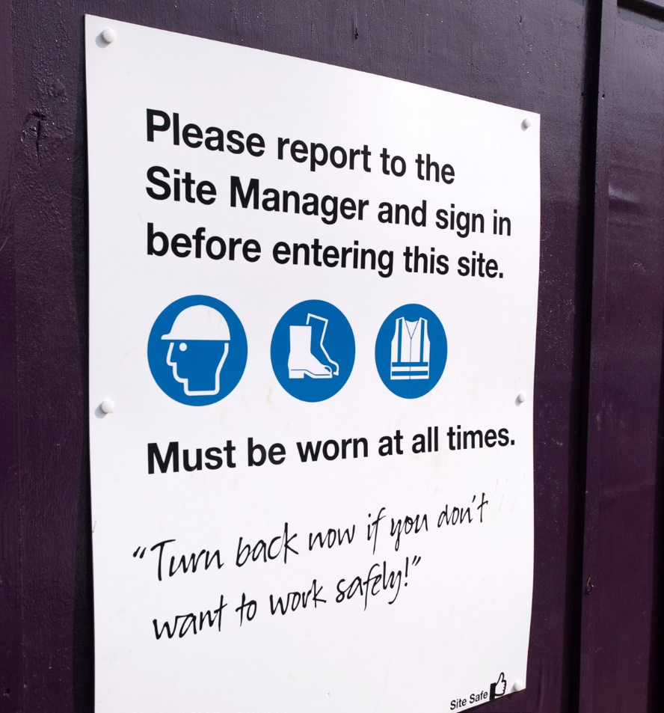



NHBC Health and safety policy Page 9

Organisational responsibilities

2.9 Appointed persons

The ANABAS senior workplace manager will appoint, in writing, an appointed person for each of NHBC Group’s premises. The name, designation and terms of reference of the appointed person will be displayed on the noticeboard of the relevant office. The appointee will be an office- based member staff at that location, unless there is a full-time facilities presence permanently on site.
The appointed person will:
l be responsible for co-ordinating health and safety
Matters relating to the office premises at which
they are located with the head of health and safety
l carry out standard compliance inspections using the ANABAS forms available through the online system
None of the responsibilities of the appointed person
will relieve line managers of any health and safety responsibilities for staff or activities carried out in
those offices; these are specified elsewhere in this policy. Accordingly, line managers will co-operate with appointed persons to enable them to discharge their responsibilities. The matters requiring co-ordination
and the means by which this will be achieved will be specified separately.

NHBC Health and safety policy Page 10

Health and safety arrangements

2.10 NHBC Group Health, Safety and
Wellbeing Committee
The organisation and terms of reference of the Health, Safety and Wellbeing Committee (Committee) are outlined below. The Committee provides a consultative forum to address the health, safety and wellbeing matters arising in NHBC Group, and to:
a) consult between management and employees with
regard to health, safety and wellbeing issues
b) promote co-operation between NHBC Group and
its employees on all matters relating to their health, safety and wellbeing
c) consider relevant health, safety and welfare matters
raised by members of the committee and NHBC Group’s employees
d) consider recommendations to be made to the
NHBC Group Board on suitable annual health, safety
and wellbeing targets
e) ensure appropriate measures are in place to audit
the implementation and effectiveness of health, safety and wellbeing matters in NHBC Group
f) receive reports of:
i
accidents and near misses, involving NHBC Group
employees and consider the effectiveness of any
action taken to prevent similar incidents from
occurring in the future

the health of NHBC Group staff and the success
of any initiatives introduced to enhance their wellbeing
ii
g) request formal inspections/audits of NHBC Group’s
work places as the Committee thinks appropriate and to receive reports of such inspections
h) identify and agree health, safety and wellbeing
training needs, communications and briefings
i) review and discuss the effectiveness of NHBC
Group’s health, safety and wellbeing procedures, where necessary make recommendations for development and improvement
j) discuss and advise on NHBC Group’s arrangements regarding the implementation of new health, safety legislation and wellbeing initiatives
k) discuss and recommend methods of improving health, safety and wellbeing awareness amongst
NHBC Group’s staff.

2.10.1 Membership
l Chair – executive director named by the Board as
having responsibility for health and safety matters
l Secretary
l Staff Association
l Human Resources
l Facilities Management
l Risk and Compliance
l Group head of health and safety
l Employee representatives:
– Inspection
– Technical Operations
– Operations Support
– Training and Analysis
– Claims
– Marketing and Communications
– Legal
– IT and BPM.
2.10.2 Secretariat
The secretariat is provided by the chair of the committee via a delegated assistant. Minutes including agreed actions will be published and distributed within two weeks of the meeting to all Committee members, the chief executive officer and ExCo.
2.10.3 Meetings
The Committee will meet at least quarterly. The chair may convene additional meetings as necessary.
NHBC Group agrees to allow committee members reasonable time away from their normal duties to attend to health, safety and wellbeing matters.
2.11 Document Review Team
Provide consultative forum and advise on reviewing documentation in line with their specialist areas where required.

NHBC Health and safety policy Page 11

Health and safety arrangements

3 Health and safety arrangements
3.1 Document issue and control
The health and safety policy is produced and controlled
by the Group’s head of health and safety. The
document will be reviewed and revised as necessary at
intervals not exceeding one year. Interim revisions will
be issued as addenda when necessary.
A copy of the latest version of the health and safety
policy will be issued to all new employees, as part of the
new starter pack, prior to them commencing work for
NHBC Group. The latest copy of the policy document will
also be made available to existing employees via the
health and safety portal on The Hub.
3.3 Planning
Planning is an essential factor of the health and safety
policy in identifying the measures required to achieve
effective risk management across the company.
3.3.1 Hazard identification, risk assessment
and risk control
At all workplaces, NHBC Group will identify potential
hazards, assess risks in accordance with legislation
and record the findings. Subsequent control measures
for the management of risk will reflect the principle of
risk elimination, where reasonably practicable, followed
by risk reduction, with the adoption of personal
protective equipment as a last resort. NHBC Group’s
managers will apply the company’s health and safety
standards to meet the specific demands of the work-
place, to ensure a safe place of work and that safe
systems of work are provided, so far as is reasonably
practicable.
The company aims to provide a safe place of work and
safe systems of work through:
l effective organisation and planning
l evaluation of risk
l identification of appropriate controls
l production of suitable and sufficient risk
assessments
l supervision, inspection, monitoring and review.
3.3.2 Legal and other requirements
NHBC Group will maintain a process for identifying and
assessing applicable legal requirements. This will be
kept up to date and communicated to employees and
other interested parties as appropriate.
3.3.3 Objectives
NHBC Group will develop and maintain documented
and measurable health and safety objectives, as
appropriate and in agreement with the NHBC Group
Boards. They will cover areas for improvement across
the company as a whole.
3.2 Application
The health and safety policy has been produced for all activities undertaken by NHBC Group. The company will adopt and implement, as a minimum, the standards
set out in the policy. NHBC Group management will
ensure that this policy is used as the basis for all health
and safety management within the company.

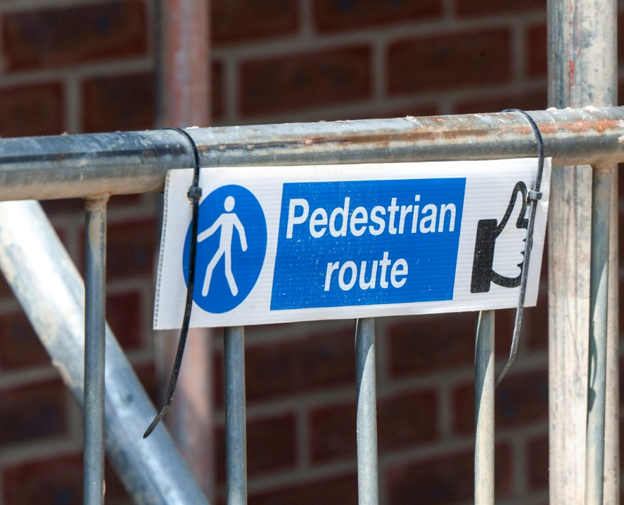



NHBC Health and safety policy Page 12

Health and safety arrangements

3.4 Implementation and operation
3.4.1 Training, awareness and competence NHBC Group is committed to ensuring that all
employees are competent to carry out their roles
and responsibilities. Competency is defined as the combination of formal training, skill, knowledge, attitude and workplace experience which, if present, allows
an individual to perform a task in an efficient manner without risk to themselves or others.
a) Line managers will ensure that all employees under
their control receive the necessary training to ensure their competence in carrying out their work for
NHBC Group without risks to the health and safety of themselves or others.
b) Line managers will ensure that all new employees, whether permanent, contract or temporary agency
staff, promptly receive an induction that covers
the requirements of this policy and details of any location-specific rules and information.
c) Records of all training, including course programmes and registers of attendance will be maintained by
the Human Resources, Organisational Development team via the Learning Management System.
d) Further information on responsibilities for training
is contained in section 2 of this document (Organisational responsibilities).
3.4.2 Consultation and communication
NHBC Group recognises that achieving the health and safety objectives it has set will depend on effective communication and consultation with employees at
all levels.
In order to ensure the health and safety of all, it is important that NHBC Group effectively communicates information about health and safety, both internally
and externally. Health and safety information is
required to flow effectively up, down and across the business, including to subcontractors and suppliers as appropriate. To ensure information reaches those it affects, the following points should be observed.
a) Health and safety will be included and discussed at
all relevant meetings.
b) The NHBC Group Board will ensure that a Health,
Safety and Wellbeing Committee is properly supported (details of the role of the Committee
are contained in section 2 – Organisational responsibilities).

c) All representatives sitting on the Health, Safety
and Wellbeing Committee are to promote the importance of health, safety and wellbeing actively
within their directorates and areas of responsibility.
In particular, they should encourage discussion
and understanding of policies and procedures. This should happen across all disciplines and not just those that are perceived as high risk, eg Inspection, Technical Services, Consultancy Services, Claims and Distribution.
d) All line managers will establish good channels of communication with everyone for whom they have
responsibility. This is not only an integral part of
good management but is also an essential part of
the feedback process necessary for the continued development of this policy and related procedures.
e) Employees wishing to express views about
health and safety should use the established line
management channels of communication by raising them with their own direct line manager in the first instance. They should also be aware of their Staff Association and/or Health, Safety and Wellbeing Committee representative so that, if they wish, their views can be expressed through these channels.
f) Where changes in the NHBC Group health and safety
policy are made, it will be the responsibility of the Group head of health and safety to ensure suitable arrangements are in place to distribute relevant information across all areas of NHBC Group.
g) All relevant health and safety information will
be distributed appropriately, making use of notice boards, The Hub and other means of communication.
h) Where NHBC group activities could affect the health
and safety of members of the public, appropriate steps will be taken to ensure they are informed of the risks and how they will be controlled.
i) Where necessary, NHBC Group has prescribed arrangements for distributing key health and safety
communications and documentation.
j) Wherever possible, it is the desire of NHBC Group to
establish successful consultation with all employees to ensure planned systems of work are effective in reducing employee exposure to risk.
k) Particular attention will be paid to ensuring that the
messages are received and understood by those
who are potentially at greater risk, including, but not exclusively, young people; disabled workers; new
and expectant mothers; and those who either do
not have English as their first language or may have difficulty understanding written communication.

NHBC Health and safety policy Page 13

Health and safety arrangements

3.4.3 Operational control
NHBC Group will maintain performance standards for activities associated with known risks to ensure, so far as is reasonably practicable, that legal compliance
is met, effective control and counter measures are applied and risk control is continually improved. Performance standards take the form of documented health and safety procedures, including generic risk assessments.
These are subject to regular review to ensure their continued suitability and effectiveness, and are amended as appropriate. Performance standards include, but are not limited to, the identified tasks in the following areas:
Purchase of goods and services, and the use of
external resources
The purchase of hazardous materials and substances; evaluation of risk associated with plant and
equipment; and the evaluation of the health and
safety competence of contractors.
Hazardous tasks
The identification of hazardous tasks; determination and approval of working methods; and any safe systems of work for controlling entry and exit of personnel to hazardous work sites.
Hazardous materials
The identification, storage and control of hazardous materials; and provision of access to material safety data and other relevant information.
Maintenance of safe plant and equipment
The provision, control and maintenance of plant and equipment; provision, control and maintenance of personal protective equipment; operator competence; and inspection and testing.

3.4.4 Emergency procedures
The NHBC Group shall prepare and periodically test,
as necessary, emergency plans and procedures appropriate to the risks identified in each workplace. This may include, but is not limited to, emergency
plans for first aid and casualty treatment, fire, rescue and evacuation procedures etc.
Emergency preparedness and response plans will be regularly reviewed, in particular after the occurrence of an emergency incident.
Emergency plans will include identification of potential emergencies; nomination of personnel to take
charge of emergency situations; actions to be taken
in an emergency; means of raising the alarm and evacuation procedures; and identification of any emergency equipment required.
The workplace-specific emergency plans should be communicated to employees during induction.
3.4.5 Discipline
NHBC Group takes the management of health
and safety very seriously and will take appropriate disciplinary action against anyone whose behaviour falls below that expected by the company in terms of health and safety.

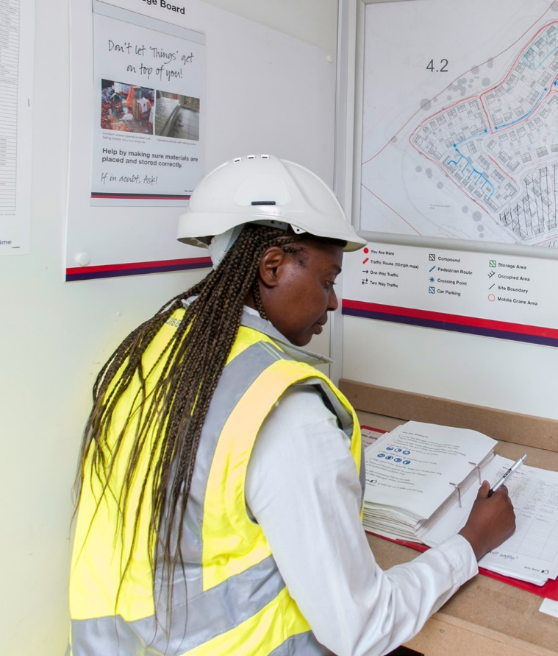

NHBC Health and safety policy Page 14

Health and safety arrangements

3.5 Performance measurement and monitoring
3.5.1 Monitoring of safety performance
NHBC Group will identify and monitor health and safety performance across all operations to ensure, so far as
is reasonably practicable, risk controls are implemented and effective health and safety policy requirements and objectives are being met. All NHBC Group premises will
be assessed by the head of health and safety annually
in order to measure compliance with statutory health and safety provisions. Inspection reports will be sent
to the facilities management company to resolve any issues identified.
The head of health and safety will ensure that an audit
of the NHBC Group health and safety management system is undertaken annually and the findings reported to the NHBC Group Board. The head of health and safety will regularly report on the management of health and safety within NHBC Group, including progress in meeting company objectives and achievement against health and safety key performance indicators, to ExCo and NHBC Group Board.
3.5.2 Accident/incident reporting and investigation
NHBC Group has identified responsibilities and standards in order to ensure that accidents and incidents are reported, investigated and reviewed as appropriate.
All injury incidents are reported and recorded and are subject to appropriate investigation. The company maintains standards to ensure that internal personnel and external interested parties are duly notified of accidents and any subsequent investigation, as appropriate and governed by legislation and policy requirements.
The company provides guidance to ensure that
each accident is investigated appropriately, in order
to establish the facts, identification of causes and corrective action required to prevent re-occurrence.
3.5.3 Accident/incident analysis
Information relating to accidents and incidents will be formally reported within the company on a regular basis. This is to enable internal collation, analysis and reporting of data as a measurement of health and safety performance.

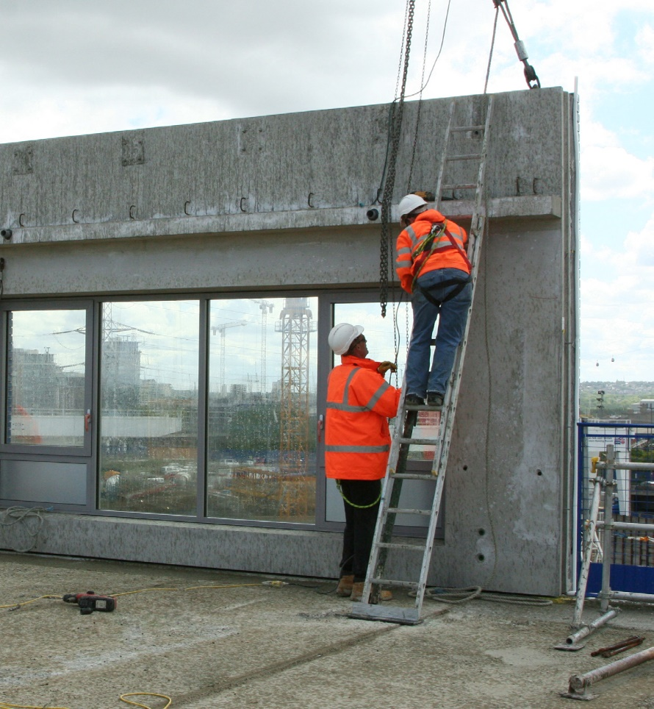



3.5.4 Auditing
NHBC Group will conduct audits of its ISO45001 health and
safety management systems on a periodic basis to determine the level of conformity against planned health and safety arrangements and to ensure that
the management system is properly implemented and maintained. ISO45001 Audits will also be carried out by a UKAS accredited external auditor
Results of audits will be forwarded to management for review and action as appropriate.
3.5.5 Management review
The head of heath and safety will review the overall performance of the health and safety management systems on a regular basis, in order to ensure their continued suitability, adequacy and effectiveness. Records of the management review shall be kept and distributed as appropriate. These records will include the details of, and improvement plan for, any required corrective action.

NHBC Health and safety policy Page 15
Se

Date |  | Version | Comments
Jun 2024 |  | 2.3 | Annual review and Doc review Committee Section added + rebrand
Jun 2025 |  | 2.4 | Facilities manager section and external audit section updated
Sept 2025 |  | 2.5 | Updated with new details of CEO
Sept 2026 |  | 2.6 | Annual Review insert of physical and metal risk management into statement



NHBC, NHBC House, Davy Avenue, Knowlhill, Milton Keynes, Bucks MK5 8FP Tel: 0344 633 1000 www.nhbc.co.uk
National House-Building Council (NHBC) is authorised by the Prudential Regulation Authority and regulated by the Financial Conduct Authority and the Prudential Regulation Authority in respect of carrying on its insurance business and its insurance distribution activities.
NHBC is registered in England and Wales under company number 00320784. NHBC’s registered address is NHBC House, Davy Avenue, Knowlhill, Milton Keynes, Bucks, MK5 8FP. Note that only certain parts of NHBC’s products and services are within the scope of UK financial services regulation. For more information on our products and services, please see our website nhbc.co.uk or your NHBC product documentation.
W353 HB1088 07/24

